Student’s name | …………………………………………………….…… | Grade | 1
Subject | Computer | Week No. | 15
Lesson Title | Explore Internet | Unit
Worksheet No. ( 15 ) (Answer)

Question A:

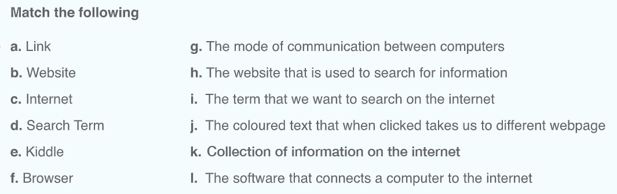
Good Luck

